**Notes on Practical Data Ethics by Rachel Thomas (FastAI and University of San Francisco)**

Course link: <https://ethics.fast.ai/>

**Intro:**

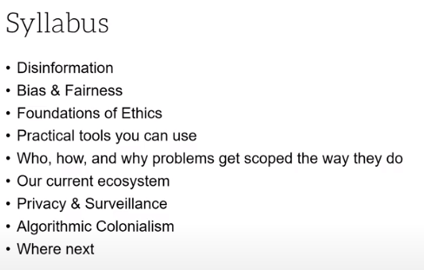

General:

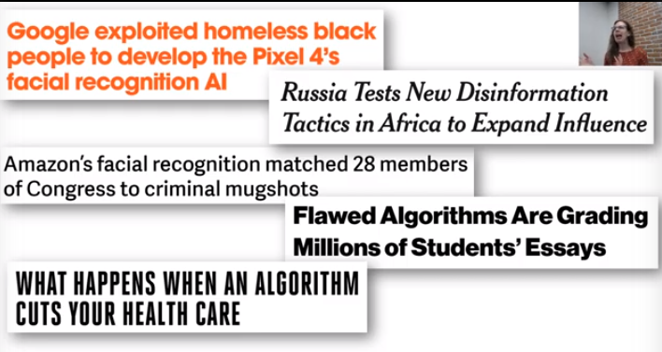

Ex1: feedback loops means your model controls the next round of data you get (usually flawed) → **automatic data poisoning**

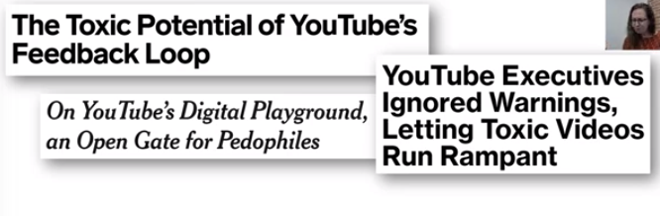

Ex2: sys implemented with no way to identify and addressue mistakes → **systematically failing on the task; no sys to debug**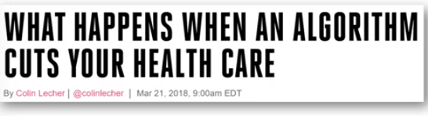

Ex3: a prof searched her name on the google and the ad showed she was arrested (left); but not on “european-like” names (bias)

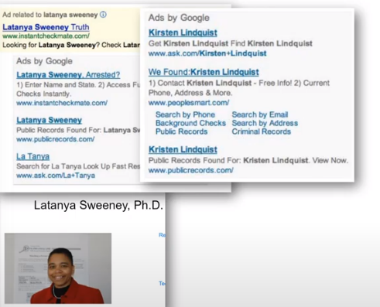

Survey literature on what topics are taught in this area:

<https://cmci.colorado.edu/~cafi5706/SIGCSE2020_EthicsSyllabi.pdf>

Brief definition

Ethics: the discipline dealing with what is good and bad; a set of moral principles

Ethics is not the same as religion, law, social norms, or feelings; it is not fixed

**Ethics is: (1) well-founded standards of right and wrong that prescribe what humans ought to do, and (2) the study and development of one’s ethical standards**

**Lesson 1: Disinformation - bigger than fake news**

Ex1:



EX2: deepfake

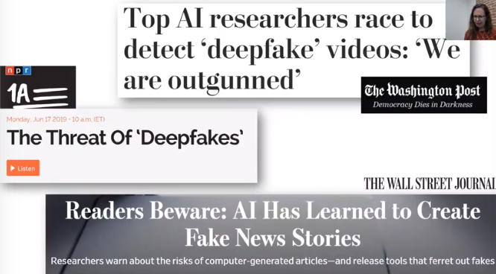

Ex3**:**

Russia’s misformation in Africa; sites offer a wide variety of stories

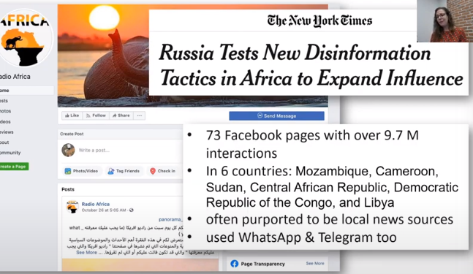

1. Not just news, but memes, videos, social media posts

Ex4:

**Fake posts/tweets that imitated black females, including rumors, hoaxes, propaganda, misleading contents, and misleading context**

1. Misinformation also includes orchestrated/planned-out misleading campaigns of manipulation

Ex3: russian operations in Africa

Ex5: Debates on white helmets - many of the sources are questionable

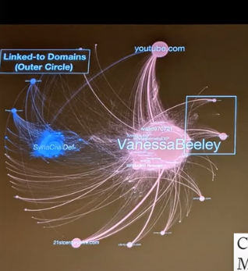

1. Amplification map

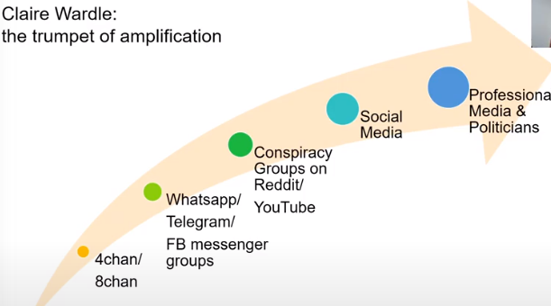

1. Disinformation undermines democracy

“Most campaigns are a carefully designed mixture of facts, half-facts, exaggerations, and deliberate lies.” - Ladislav Bittman (USSR)

1. Disinformation **pollutes** our information environment

Even though dissidents risked their lives, they are discredited by endless questions like whether their pic was fake or old; censorship now works by flooding the environment with information (whistle drowning)

1. **Hack-and-leak**

Mix fake and real documents and build a story,

Ex6:

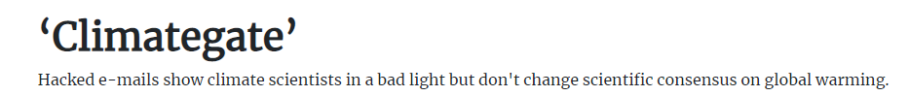

Ex7: Hilary Cliton’s emails

Ex8: Fancy Bears & International Olympic Committee

1. **The tech platforms (unintentionally) incentivize and promate disinformation**

* Their design and architecture
* Their recommendation systems
* Their business models

Ex9: Youtube recommendation system promoted a Russian site thousands of times for analysis on Muller’s report

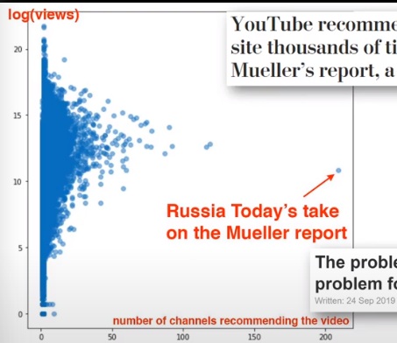

**Short-term metrics in machine learning, like clicks or likes, can be taken advantage of!**

Many online environments are designed to be attractive. Social media platforms may by design, tilt users away from considering accuracy, but encourage users to rapidly scroll and spontaneously engage; mixing contents of serious news and emotionally engaging ones (baby pics & cat videos)

**NLP, computer vision, and other ML systems**

**Ex10: GPT-2 generated text (misuses): reddit posts and unicorn text**

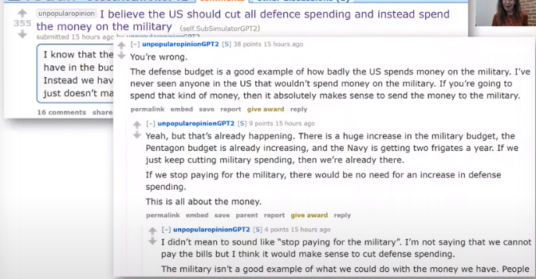

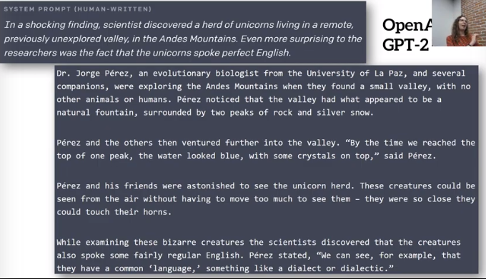

Ex11: fake generated Linkedin account

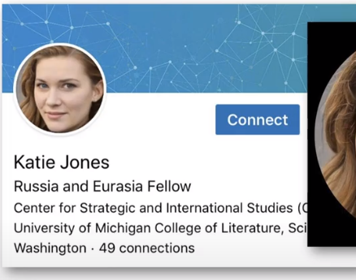

Ex 12: this person doesn’t exit → randomly generated human pic

<https://www.thispersondoesnotexist.com/>

Ex 13: generated online comments on FCC → hard to create a detection program

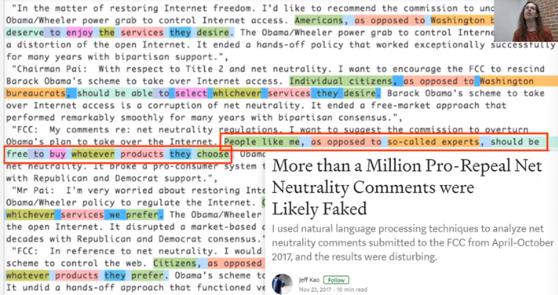

Howard from Fast.AI said “**We have technology to totally fill Twitter, email, and the web up with reasonable-sounding, context-appropriate prose, which would drown out all other speech and be impossible to filter.”**

1. Extreme viewpoints can be normalized when we think we are around others who hold those views

Ex 14: shooters posted in social medium and got attention/teases

1. **What should we do to all kinds of misinformation (important!!!)**
2. Practice good social media habits
3. Keep perspective

Goals of misinformation: weaken out trusts on institutions and others

1. Strengthen institutions such as journalism, education, universities, and non-partisan gov depts

Ex 15: Pinterest gave authority of vaccine search back to WHO and CDC

<https://newsroom.pinterest.com/en/post/bringing-authoritative-vaccine-results-to-pinterest-search>

1. Double check different sources of information, e.g., tweets and the actual news link

***According to the prof, a detection system of misinformation cannot be easily automated in deep learning, but very simple for humans to do. Even edge cases are not neglectable.***

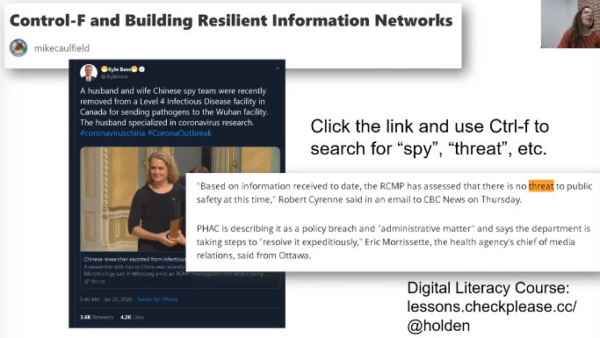

1. Some other approaches, as in:

<https://www.technologyreview.com/2019/12/12/131605/ethical-deepfake-tools-a-manifesto/>

* Detection of fakes/disinformation (arm race; hard to be automated) → specifically you can have two algorithms learning misinformation and the better one can get better fakes. Generative adversarial networks (GAN)?
* Responsible development tools (**Milestone Tech aims at developing them**)
* Address the ecosystem
* Teat as cybersecurity issues
* Verification tools
  + *A digital analogy of Castro holding a newspaper saying he was dead*
* Limit who can use the tool & discourage malicious uses
  + Limiting: carefully vet clients or constrain usage
  + Discouragement: clear disclosure, consent protection, detection friendliness, hidden watermarks, usage logs, use restrictions
  + Supporting ethical synthetic media tools → it’s not a way to solve the prob, but mitigate it

Resources on digital political ethics:

<https://citapdigitalpolitics.com/?page_id=1911>

Ex16: [Facebook fact-checker is not really bi-partisan](https://www.nytimes.com/2019/11/02/opinion/facebook-zuckerberg-political-ads.html)

10. Experts on the topic of misinformation

Clarie Wardle <https://cyber.harvard.edu/people/dr-claire-wardle>

Renee DiResta <http://www.reneediresta.com/>

Zeynep Tufekci <https://sils.unc.edu/people/faculty/profiles/Zeynep-Tufekci>

Kate Starbird <https://www.hcde.washington.edu/starbird>

Shafiqah Hudson <https://www.netrootsnation.org/profile/shafiqah-hudson/>

Joan Donovan <https://www.hks.harvard.edu/faculty/joan-donovan>

Guillaumae Chaslot <https://www.youtube.com/watch?v=Et2n0J0OeQ8>

Aviv Ovadya <https://aviv.me/>

Becca Lewis <https://datasociety.net/people/lewis-becca/>

Section 2: Bias and Fairness

Part 1: Lec2 reading: Various Fairness definitions and their politics (Arvind narayanan)

“Trolley problems” for fairness in ML

Common thread: predictive accuracy → limited

1. Statistical bias:

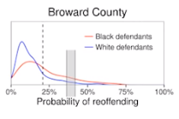

The window part only shows part of the truth!

1. Data bias:

*Problem: my model predicts data correctly, it is data bias, not the algorithm’s fault.*

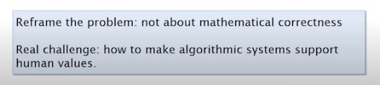

**Dimensions of fairness:**

1. Group fairness (demographic groups)

A binary classifier from different perspectives

* Stakeholder: predictive value (true positive)
* Defendant: False Positive (wrong positive predictions)
* Society: demographics

1. Individual fairness (basic version: equal thresholds)

* In general it is impossible to pick a single threshold for all groups that equalizes both FPR and FNR

(c) Process fairness

* Hard to be quantified as an optimization problem

Two types of **harms** brought by unfairness:

**Allocative harms**: a system is biased against particular populations

system withholds opportunities (hiring, justice, etc.); economical harms; discrete transactions and immediate effects

Ex: racial discrmination

**Representational harms**: biased systems model the world in a manner that preferences certain viewpoints

system reinforces subordination of a group (stereotyping, cultural denigration); social harms, long-term effects

Ex: google english - turkish translation keeps gender bias

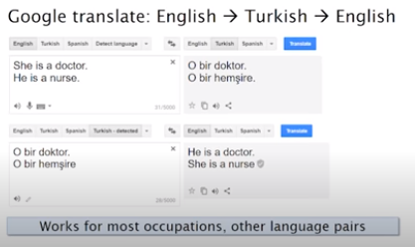

Ex: search the keywords “CEO” returns males on Google search

Ex: another wrong role labeling case

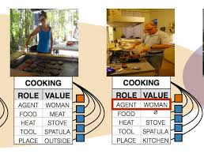

**A bias analysis: (1) representativeness of data, (2) intended and unintended uses, (3) should the pre-leased models have similar obligations, and (4) how we should debiase the models**

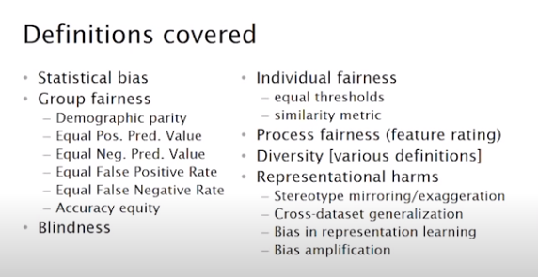

Part 2:

Microsoft developed a datasheet for datasets that can help us reduce biases (taken from hardwares)

<https://arxiv.org/abs/1803.09010>

A similar work in NLP:

<https://www.aclweb.org/anthology/Q18-1041.pdf>

Lessons learned from archivists

<https://arxiv.org/pdf/1912.10389.pdf>

The datasheet’s structure: motivations, composition, collection process, pre-processing/cleaning/labeling, uses, distribution, and maintenance

Part 3:

**Mathematical methods of biases**

1. **Demographic Parity** states that the proportion of each segment of a protected class (e.g. gender) should receive the positive outcome at equal rates.

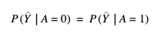

Positive Rate (A=0) = Positive Rate (A=1)

Use DP when:

1. We want to make a real-world change on certain groups
2. We have knowledge of possible biases
3. We have a plan to support the unprivileged group and to prevent the reinforcement of the biases
4. **Equal Opportunity** states that each group should get the positive outcome at equal rates, assuming that people in this group qualify for it.

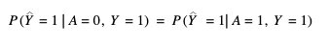

True Positive Rate (A=0) = True Positive Rate (A=1)

Use EO when:

1. Strong tendency to predict one of the classes (e.g., fraud detection)
2. Introducing False Positives are not costly to the user nor the company (e.g.: wrongly notifying a customer about fraudulent activity will not be necessarily expensive to the customer nor the bank sending the alert)
3. The target variable is not considered subjective (e.g., labelling who is a ‘good’ employee is prompt to bias and hence very subjective)
4. **Equalised odds** means: correctly identify the positive outcome at equal rates across groups (same as in Equal Opportunity), but also miss-classify the positive outcome at equal rates across groups (creating the same proportion of False Positives across groups)

True Positive Rate (A=0) = True Positive Rate (A=1) , and False Positive Rate (A=0) = False Positive Rate (A=1)

Used when:

(1) both predicting true positive (e.g., correctly identifying who should get a loan drives profits) and false positive (e.g.,reducing the grant of loans to people who would not be able to pay back) are important

(2) The target variable is not considered subjective (e.g., labeling who is a ‘good’ employee is prompt to bias and hence very subjective)

**Part 3: Five sources of harm/biases(Huresh & Guttag 2019) (mixed with Rachel’s class notes)**

<https://arxiv.org/pdf/1901.10002.pdf>

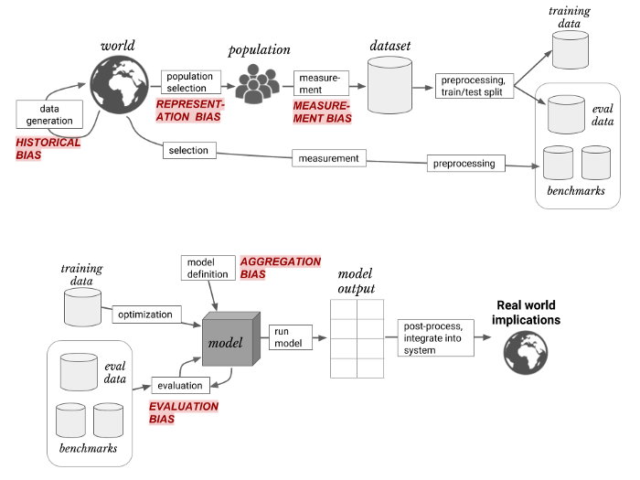

* **(1) Historical bias** arises even if the data is perfectly measured and sampled, if **the world as it is or was** leads a model to produce outcomes that are not wanted → *fundamental issue in the pipeline*

Ex1: a “crime” dataset reflects the historical fact that many of them happened in poor neighborhood

Ex2: image search In 2018, 5% of Fortune 500 CEOs were women (Zarya, 2018). Should image search results for “CEO” reflect that number? Ultimately, a variety of stakeholders, including affected members of society, should evaluate the particular harms that this result could cause and make a judgment. This decision may be at odds with the available data even if that data is a perfect reflection of the world. Indeed, Google has recently changed their Image Search results for “CEO” to display a higher proportion of women.

* **(2) Representation bias** arises if Pˆ (P_hat: the probability distribution of the input) is a distribution that samples too few examples from a particular part of the input space (this can include either or both of x, the features, or y, the labels).

The reason for this bias is related to the **mismatch of data population**.

Ex: most pic data from ImageNet came from the USA, so it is not representative to pics of China or India

* **(3) Measurement bias** means the wrong ways of measure adds a second layer of noise.

Ex1: predictive policing often uses arresting rate as its measure of “crime” and “riskiness”. Since the arrest rate is also related to minority communities, they are the representatives of crimes or risk.

Ex2: correlation & causation (EHR: Electronic health record)

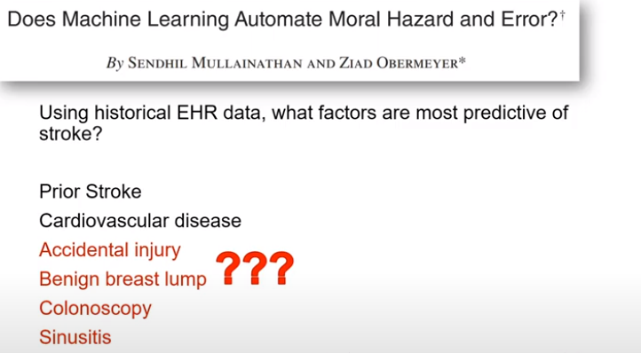

→ we haven't actually measured stroke, but symptoms, doctor’s visits, and diagnosis...

* **(4) Aggregation bias** arises when a one-size-fit-all model is used for groups with different conditional distributions, p(Y |X). Their conditions of X are different.

Ex1: Diabetes patients have known differences in associated complications across

Ethnicities; a single model is not enough to capture different Xs.

* (5) **Evaluation bias** occurs when the evaluation and/or benchmark data for an algorithm doesn’t represent the target population; often trained on wrong dataset

Ex: low performance of facial recognition on dark skinned women

* (6) **Deployment bias** arises when there is a mismatch between the problem a model is intended to solve and the way in which it is actually used.

Ex: Algorithmic risk assessment tools are models intended to predict a person’s likelihood of committing a future crime. In practice, however, these tools may be used in “off-label” ways, such as to help determine the length of a sentence.

Part 4: Rachel’s lecture

Ex1: Facial recognition performances on different groups

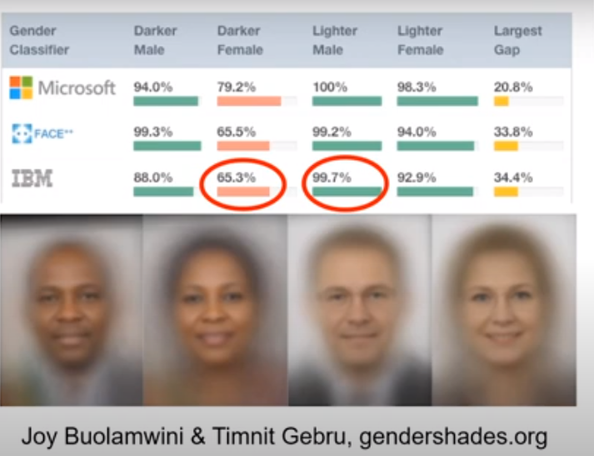

Ex2: Recidivism algorithm used in prison sentencing

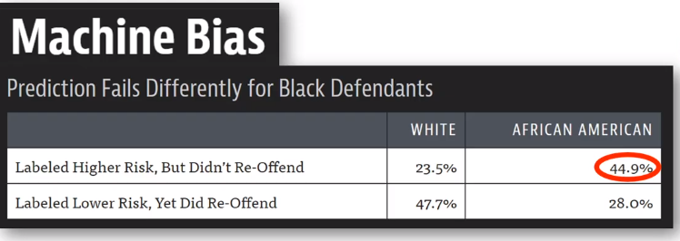

African Americans FPR is higher on the arresting decisions in this study

These predictive models create a feedback loop when the model controls the next round of data so the leaning is more skewed.

Ex3: Online ad delivery



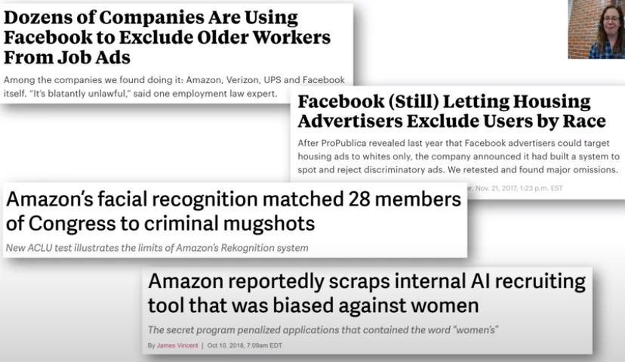

**One way to regular AI** is to consider what human rights & civil rights we want to protect: housing, education, employment, criminal justice, voting, cultural respect, and medical care...

Ex4: more racial biases

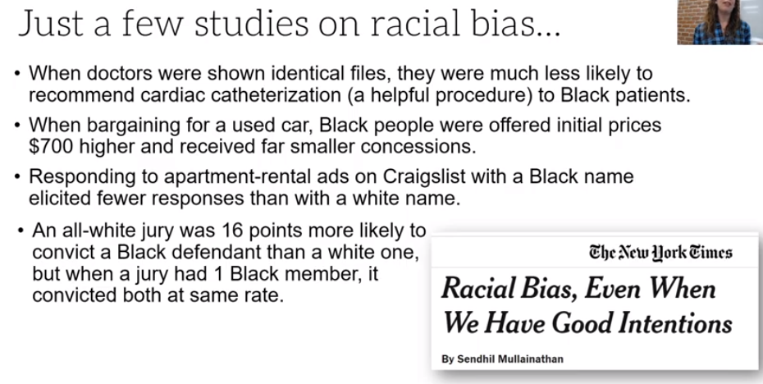

**Why does algorithmic bias matter**

1. Machine learning can amplify biases

Ex5: In LinkedIn 14.6% of the surgeons are female, thus the true positive in the gender prediction is 11.6% (historical + representation biases)

1. Algorithms are used differently than human decision makers

“The privileged are processed by people; the poor are processed by algorithms” (Cathy O’Neil)

1. Feedback loops make things worse
2. Technology is power and with that comes with responsibility

Meatrics issue: humans decide which error function to minimize (or what success score to maximize)

Ex5: binary classification in different applications

**Medical diagnostics: FN is more important**

**Spam detection: FP is more important**

**Riskiness of defendants: FP & FN are both important**

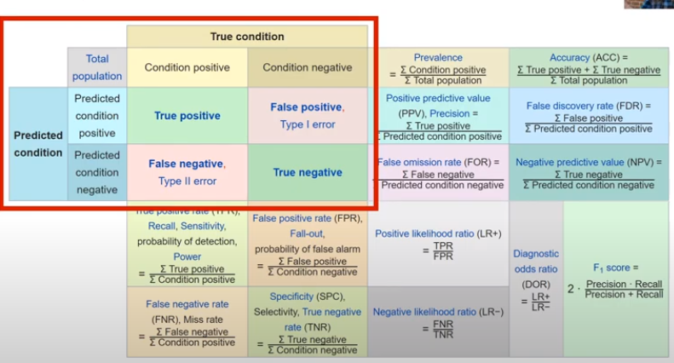

Bias is not the whole issue:

* Accuracy is not everything

Ex6: unethical questions asked to improve the judgment accuracy

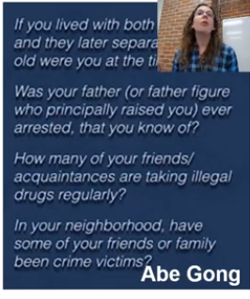

* Ex7: Facial Recognition in Baltimore

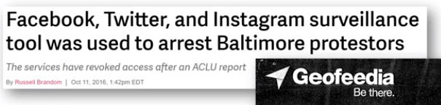

**Algorithmic “fairness” is not justice (fairwashing trick)**

The risk of rationalization: it is possible to forge a fairer explanation from a truly unfair black box.

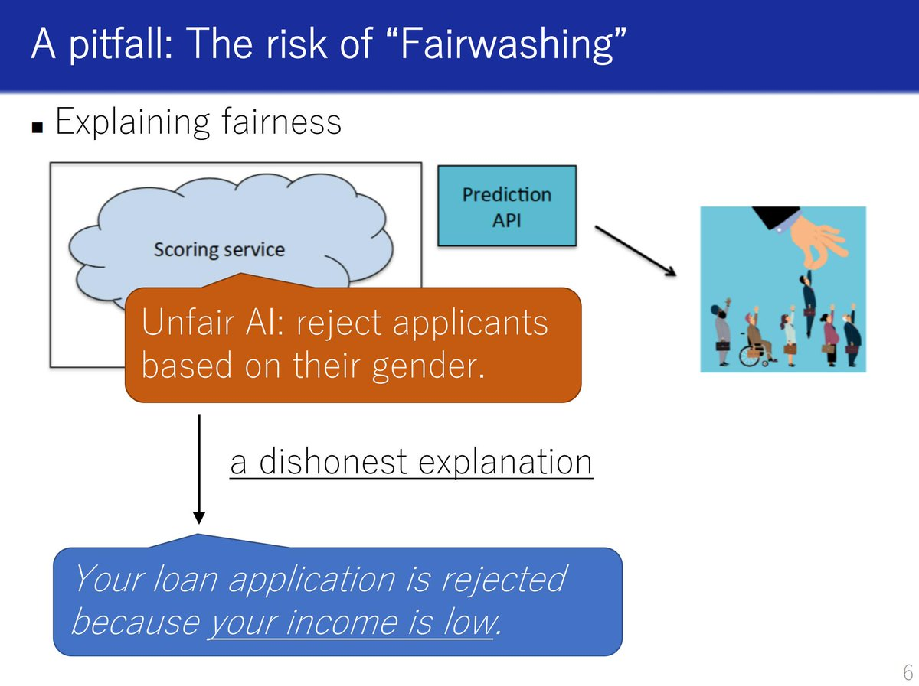

**Solutions to biases and unfairness**

1. Analyze a project at work

* Questions to ask about AI
  + **What bias in the data?**
  + **Can the code and data be audited**
  + **What are the error rates in different groups?**
  + **What is the accuracy of a simple rule-based alternative?**
  + **What processes are in place to handle apples or mistakes**
  + **How diverse in the team that builds it?**

1. Work with domain experts and those impacted
2. Increase diversity in your workplace
3. Advocate for good policy
4. Be on the ongoing outlook for bias (keep checking)

Section 3: Toolkit for Ethics in Tech Industry

Part 1:

Ex1:

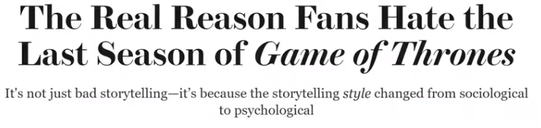

General audience’s attention is more on the psychological aspects of the tech industry (e.g., Zuckerberg, Sandberg, Dorsey, Benzos) instead of sociological background like business models, tech advances, political environment, (lack of) meaningful regulations, economic & political forces fueling wealth inequality & lack of accountability.

“Well-run societies don’t need heroes.”

1. Three schools of ethics
2. Deontological ethics: focus on rights, principles, and duties

These principles can include autonomy, dignity, justice, fairness, transparency, consistency, and more. They may conflict.

Ex2: some deontological ethical rules

* The golden rule: mutual treatments
* Kant’s formula of humanity: I should always treat other persons as ends in themselves, never just means to an end
* Rights Approach: which option best respects the rights of all who have a stake?
* Justice Approach: which option treats ppl equally or proportionally?

Deontological questions for tech → common pattern in many ethical documents

* **What rights of others and duties to others must we respect?**
* **How might the dignity and autonomy of each stakeholder be impacted by this project?**
* **What considerations of trust and of justice are relevant to this design or project?**
* **Does this project involve any conflicting moral duties to others, or conflicting stakeholder rights? How can we prioritize these?**

Ex3:

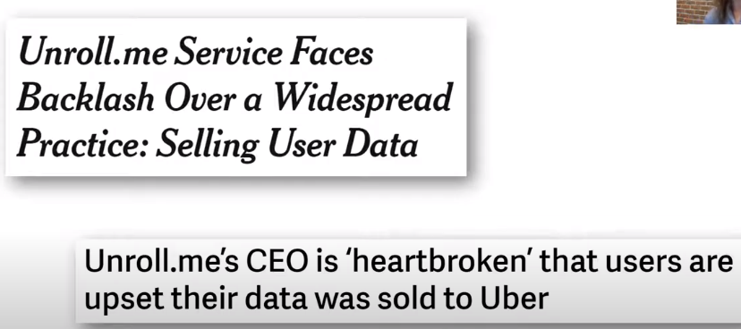

1. Consequentialist ethics

Use consequences as the standard to view whether an action is ethical or not.

Ex4:

**Utilitarian approach: which option will produce the most good and do the least harm**

**Common Good approach: which option best serves the community as a whole, not just some members?**

Ex5:

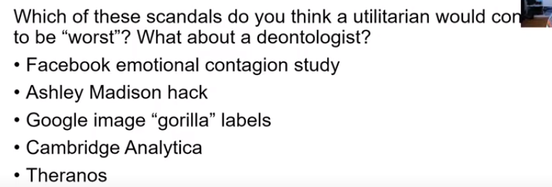

1. Virtue Ethics

This kind of ethics focuses more on the character or actor traits instead of actions or consequences.

The need of people with well-habituated virtues of moral character and well-cultivated, practically wise moral judgment to fill the gap.

Ex6: questions Virtue Ethics asks

* **What design habits are we embodying? Are they habits of excellent designers?**
* **Will this design/project weaken any important human habits, skills, or virtues that are central to human excellence? Will it strengthen any?**
* **How confident are we that we will individually, and as a team/organization, be proud to have our names associated with this project one day?**

1. Other ethical lenses: perspectives from other cultures such as Maori
2. Another way is to summarize the **five ethical lenses** (importance from low to high)

For commercial activities, 1-4 are useful

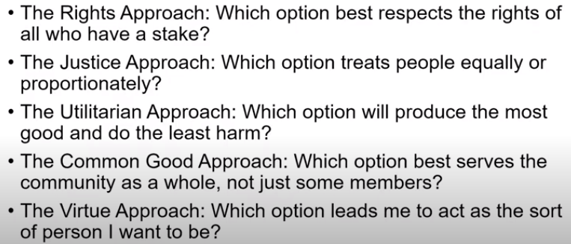

**2. An Ethical Toolkit for Engineering/Design practice**

**Tool 1: Ethical Risk Sweeping**

Ethical risks are choices that may cause significant harm to persons or other entities

Institute regularly schedules ethical risk-sweeping practices.

Keep thinking about risks. **Assume you missed some risks in initial project development phase; reward team members for spotting new ethical risks**

**Tool 2: Ethical Pre-mortem and post-mortems**

Pre-moterms:

* **How could this project fail for ethical reasons?**
* **What blind spots would lead us into it?**
* **Why would we fail to act?**
* **Why/How would we choose the wrong action?**
* **What systems/processes/checks/failsafes can we put in place to reduce failure risk?**

Ex6:





Post-mortems: what did we learn from the failures of the deployment?

**Tool 3: Expanding the ethical circles**

Two ways failing to see risks: (1) group thinking, (2) lack of diversity of life experiences, values, worldviews, identities, abilities, and personality styles (“Bubble” mentality) and (3) company’s obligation only to maximize shareholder profit (“Friedman Fallacy”)

* **Whose interests, desires, skills, experiences, and values have we simply assumed,rather than consulted?**
* **Who are all the stakeholders who will be directly affected by our product? How have their interests been protected? How do we know what their interests really have - have we asked?**
* **Who that we didn’t expect to use it might use this product, or for purposes we didn’t initially intend?**

Ex7: only 12% of the ML workers are women; 41% ended up leaving (compared to 17%)

Ex8: UW’s experiments on diversity in stakeholders

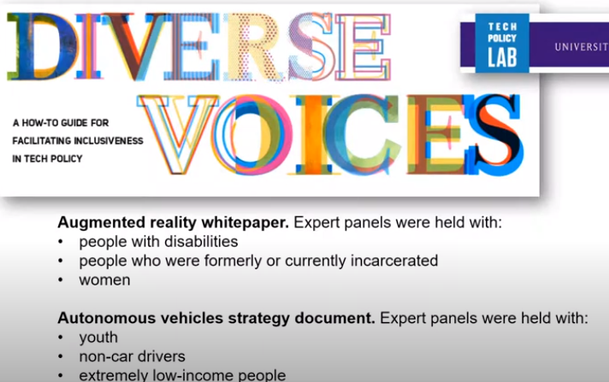

**Tool 4: Case-based analysis**

* **Identify similar or “paradigm” cases that mirror the present case**
* **Identify relevant parallels between all the cases**
* **Evaluate choices made and outcomes of the paradigms**
* **Identity parallel risks, opportunities, solutions, risk mitigation strategies**

A very good course for case studies

**Data: Past, Present, and Future**

<https://github.com/data-ppf/data-ppf.github.io/wiki/Syllabus>

**Tool 5: Remembering the Ethical benefits of creative work**

* **Why are we doing this, and for what good ends?**
* **Will society, our customers, or the world really be better off with this tech than without it? Or are we trying to generate inauthentic needs or manufactured desires, simply to justify a new thing to sell?**
* **Has the ethical benefit of this technology remained at the center of our work and thinking?**
* **What are we willing to sacrifice to do this right?**

**Tool 6: Think about the terrible people**

* **Who will want to abuse, steal, misinterpret, hack, destroy, or weaponize what we built?**
* **Who will use it with alarming stupidity or irrationality?**
* **What rewards/incentives/openings has our design inadvertently created for those people?**
* **How can we remove those rewards/incentives?**

**Tool 7: Closing the loop - Ethical feedback and iteration**

* **Remember than this design is never a finished work**
* **Identify feedback channels that will deliver reliable data on ethical impact**
* **Integrate the process with quality management and user support**
* **Develop formal procedures and chain of responsibility for ethical iteration**

Ex 9:

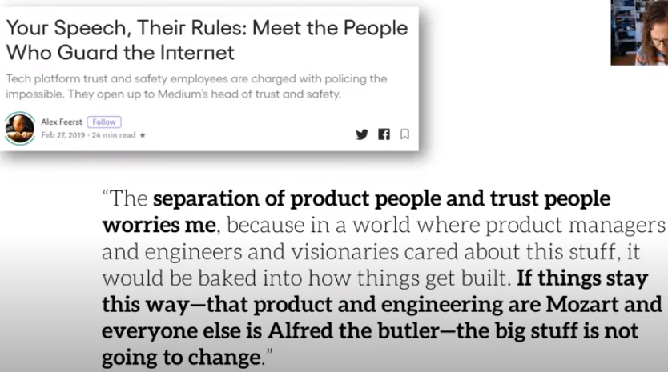

There is a conflict between product/engineering ppl and trust management ppl in a company

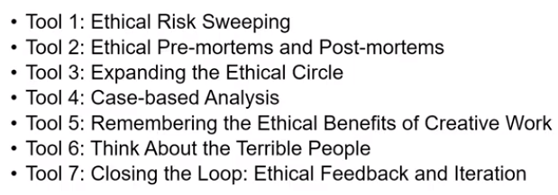

*Students feedback: #3 is crucial*

3. Both policies and ethical industry behavior are necessary

Section 4-1: Privacy and surveillance

Ex1:

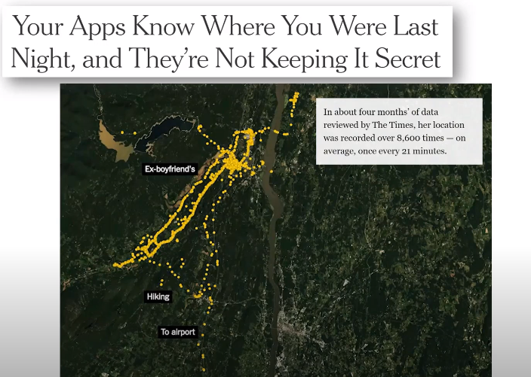

Ex2:

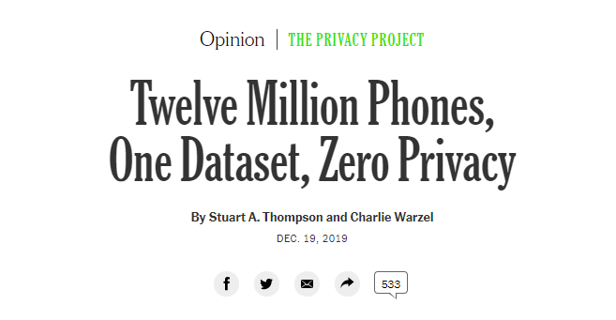

Ex3:

Delivery data was sold

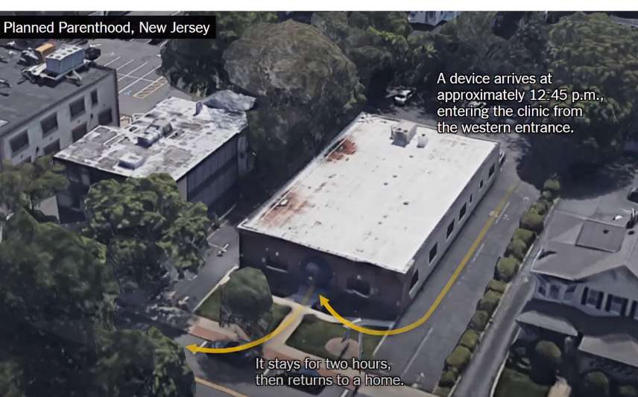

Ex4: Grindr and OKCupid asked personal details

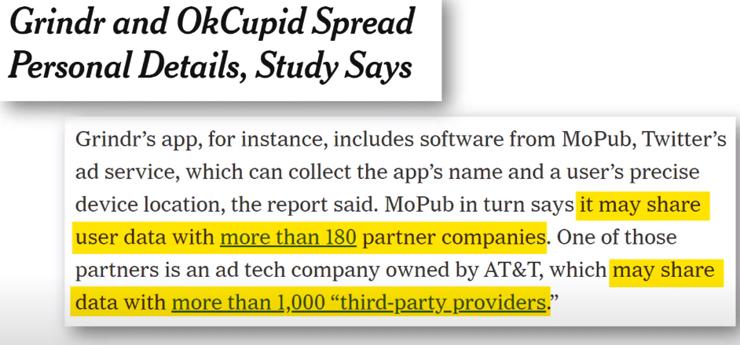

Ex5: children and facial recognition database

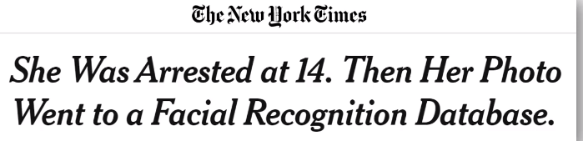

Ex6: Facial recognition and Woody Harrelson

*New York police had a problem with facial recognition software. Security camera images of a beer thief were too blurry to identify, so police replaced the blurry face with an image of the actor Woody Harrelson. The software found a match. Police made an arrest. Georgetown University's Center on Privacy and Technology called out this episode. Police insist facial recognition is just a tool. Nobody is arrested solely for resembling Woody Harrelson.*

Ex7: metro cards and automatic scan

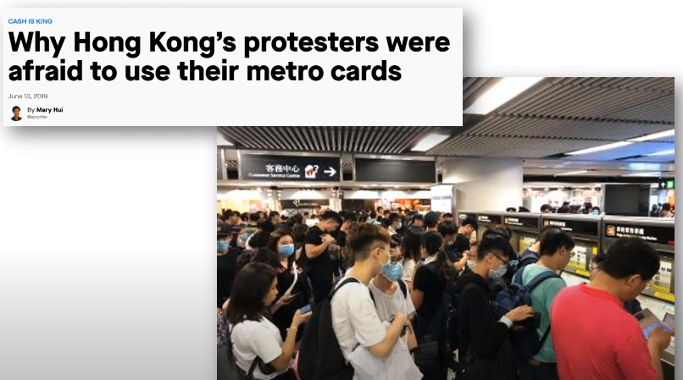

History of surveillance

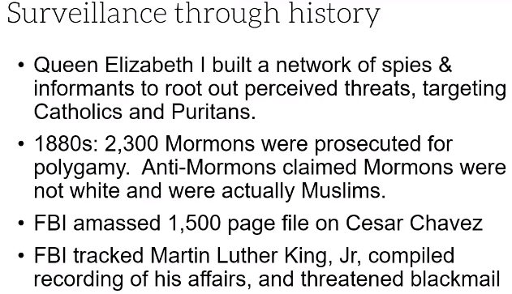

We watch those who are “other” (poor ppl, minority, immigrant, heretic,..) Surveillance becomes a tool to stop marginalized ppl from achieving power.

Ex8:

**“The stakes are too high in criminal investigations to rely on unreliable — or wrong — inputs,”**

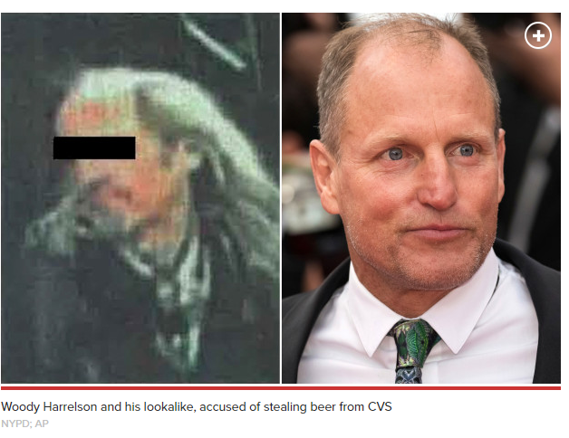

<https://www.theguardian.com/us-news/2019/may/16/where-everybody-knows-your-face-woody-harrelson-photo-used-to-spot-thief>

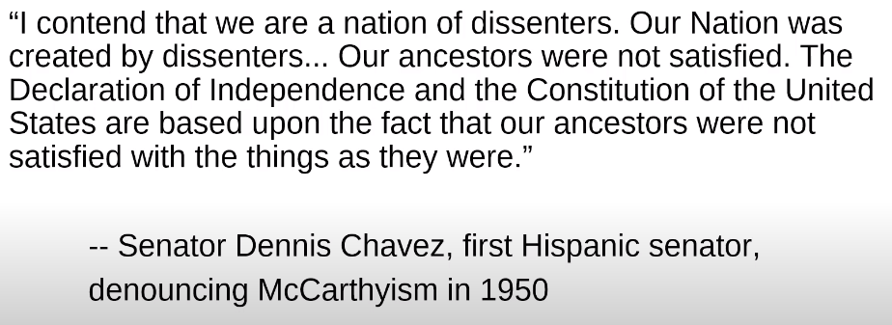

Ex9: police used FR to detect possible protestors (“before they hurt someone”)

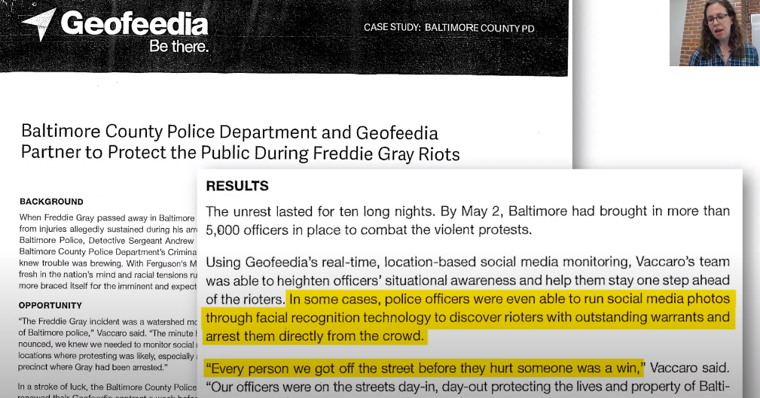

**What you need to know about government and technology (US)**

* **Opaque**

Ex10: predictive policing, NYC’s auto-decision making, and hiding

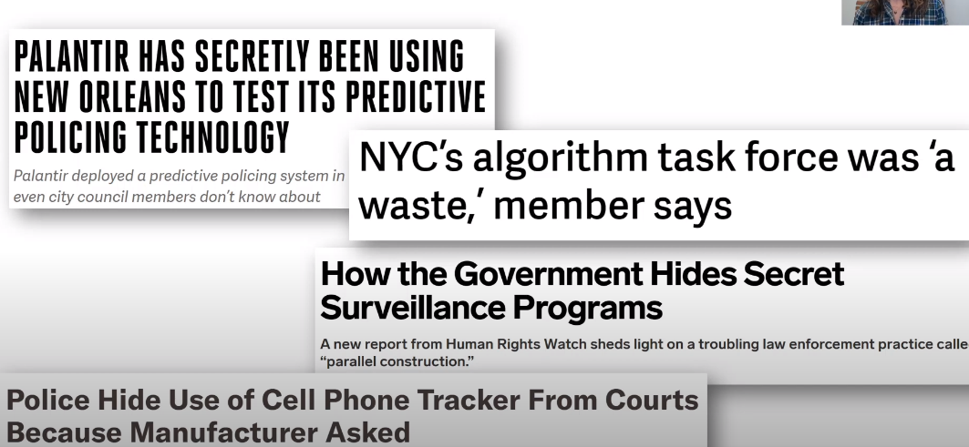

* **Restrictive NDAs**
* **Typically not evidence-based**

Ex11:

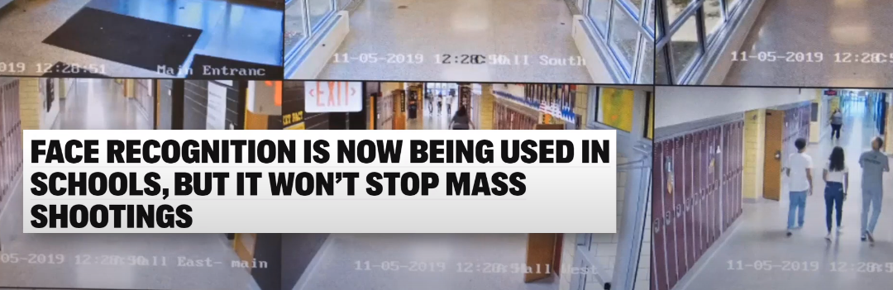

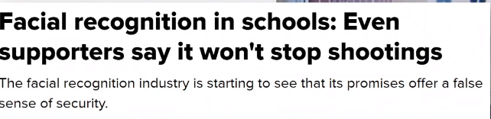

Ex12: private companies and public service

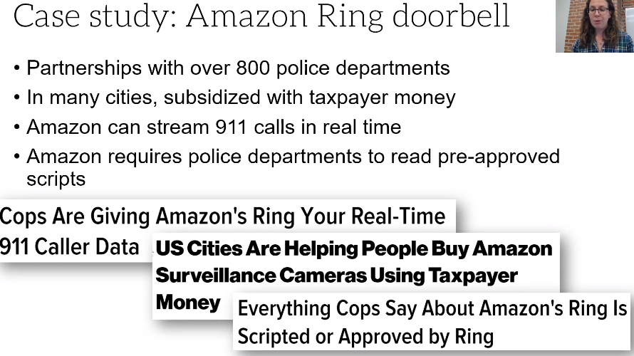

NBC says the Ring service is not helpful

<https://www.nbcnews.com/news/all/cute-videos-little-evidence-police-say-amazon-ring-isn-t-n1136026>

* **Dysfunctional disconnect**

Ex13: Rachel asked what are pros and cons supporting the surveillance systems

**Pros: (1) public safety, (2) catch criminals, and (3) convenience/efficiency (board a plane faster)**

**Cons: (1) massive social control (Xinjiang China), (2) harm the most vulnerable, (3) data collected for one reason can be used for other purposes, (4) internal threats are always the biggest threats, (5) stop dissents, and dissents are crucial for social progress**

**Surveillance concerns either way:**

Ex14: IBM & Holocaust in the 30s

https://www.theengineroom.org/dangerous-data-the-role-of-data-collection-in-genocides/

Ex15: India forced HIV patients to forgo treatment by using intrusive biometric ID

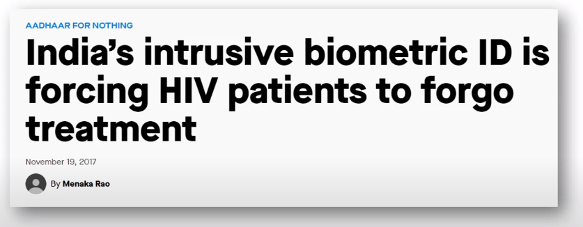

Ex 16: ICE

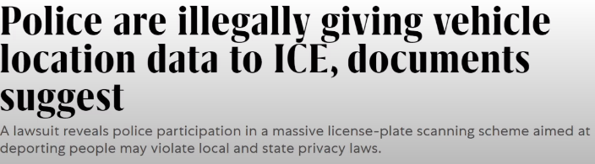

Ex17: the poor selling data for money

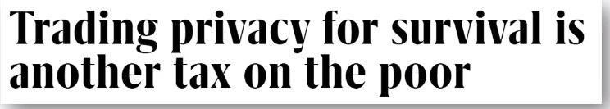

Ex18:

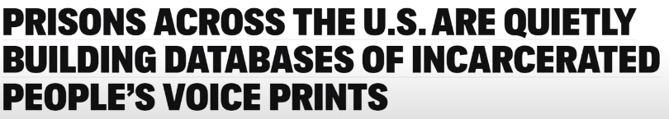

Ex19:

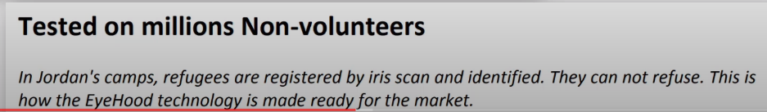

Scholar in this area: Frank Pasquale

<https://www.brooklaw.edu/Contact-Us/Pasquale-Frank>

Ex20: demographics of facial recognition bans in different cities

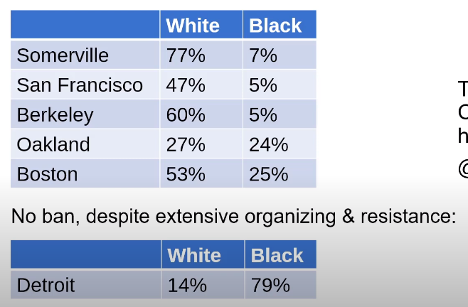

<https://urbanomnibus.net/2020/01/caught-in-the-spotlight/>

Ex21: Japanese American data was shared for other purposes

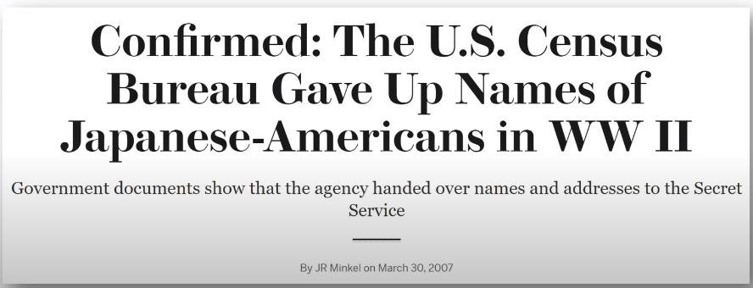

Tim Wu in *How Capitalism Betrayed Privacy*: you must assume that any person data that Facebook and Android keeps are data that governments around the world will try to get or that thieves will try to steal.

Ex22: undocumented immigrants and driver’s liecense database

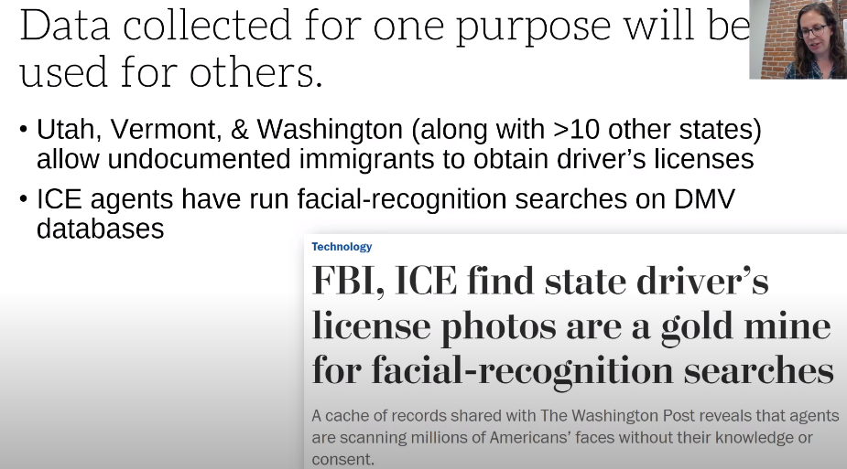

Ex23: DHS considered how to punish states that deny access to driver records

<https://www.buzzfeednews.com/article/hamedaleaziz/dhs-memo-drivers-records-sanctuary>

Data can contain errors

Ex24:CA gang database

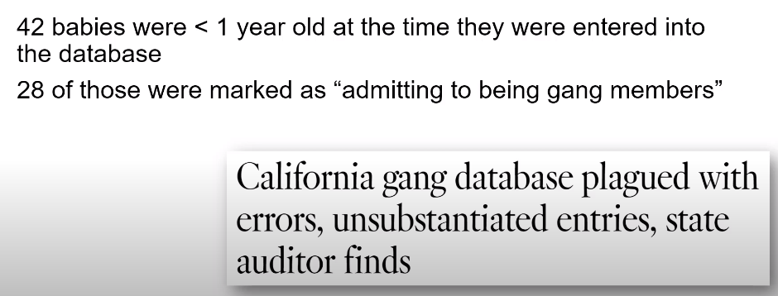

Ex25: Federal trade commission’s error rates

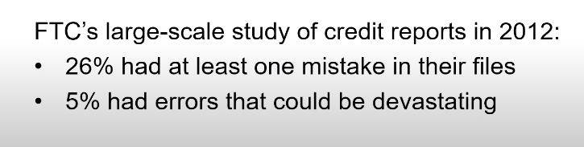

Ex26: more on policing softwares

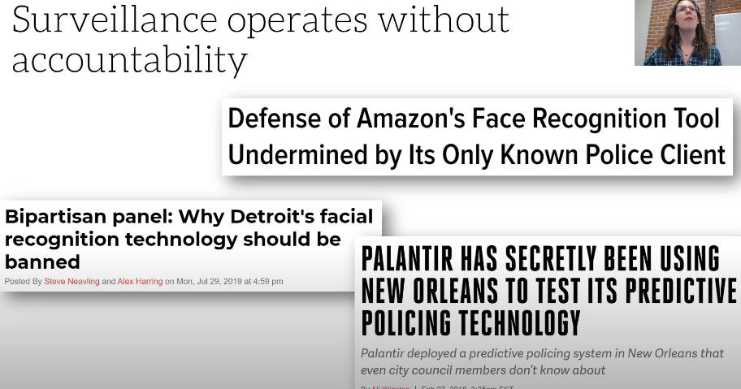

Ex27: internal threats are often the biggest threat

Saudi Arabia infiltrated twitter

Ex28: police abusing confidential databases

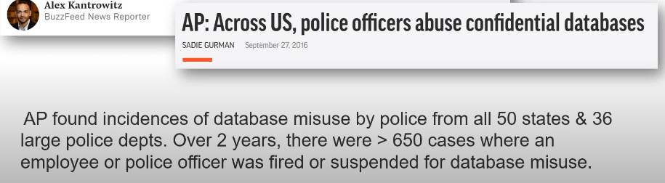

**Rebuttals to objections**

1. Don’t people know what they are getting in to when they use these services?

* It would take average American 40 minutes a day to read every privacy policy they saw
* Companies rely on manipulative design tricks to get you to spend more time and money and share more data
* Facebook can create profiles for ppl who never use FB
* Many employees require the use of certain tech
* In many cases, people need to opt out modern life
* No granular control (all or nothing)

1. If you have done nothing wrong, you should have nothing to hide

* Some groups face higher scrutiny
* With surveillance you can get somebody on anything

Ex29: tweet from a researcher on CV and privacy

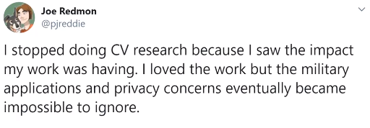

Ex30: Data will be used for other purposes

Grindr, TikTok are from China

Clearview AI’s entire client list was stolen

Part 2:

**Do Artifacts have politics??**

Social ontology → all objects have strong social meanings

**The Moral Character of Cryptographic Work**

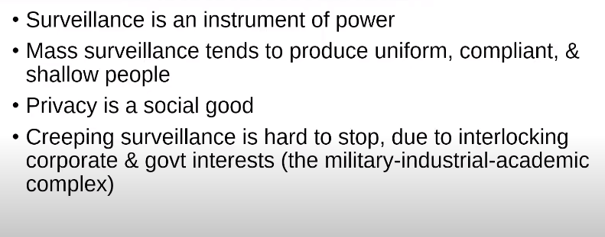

**Steps toward solutions**

1. **Proposals that won’t solve it**

***Problem: Should we pay ppl for their data? NO***

* **Failed to treat privacy as a public good.**
* **Failed to treat privacy as a human right**
* **Privacy becomes a luxury for the rich**
* **Virtually impossible for individuals to calculate the values: spread over time, changes with aggregation (Abdulrahim, Famoroti)**
* **Puts burden of time & education on consumer, not on firms that have all the power**
* **Would entrench the asymmetric and exploitable relationship between firms and individuals**

**Data privacy should not be seen as a property right, but a human right.**

**What about differential privacy?**

**Critiques (from Rogaway)**

* **Implicitly assumes the database owner is the “good guy”**
* **Treats harms as individual, not community-wide**
* **Rarely considers alternative of collecting less data**
* **Gives corporate a means for white-washing the risks**

1. **What motivates companies to change**

**Ex1: Myanmar and FB**

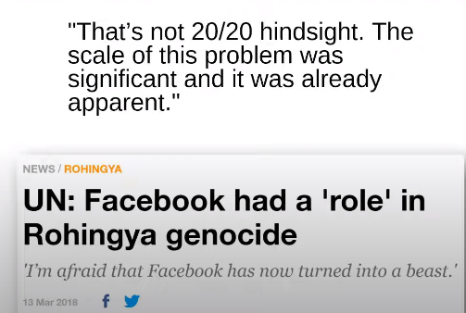

**--- FB hired “dozens” of Myanmar language content reviewers; meanwhile, facing the possible penalty, it hired 1,200 in Germany.**

1. **Hope from history**
2. **Privacy as a public good**

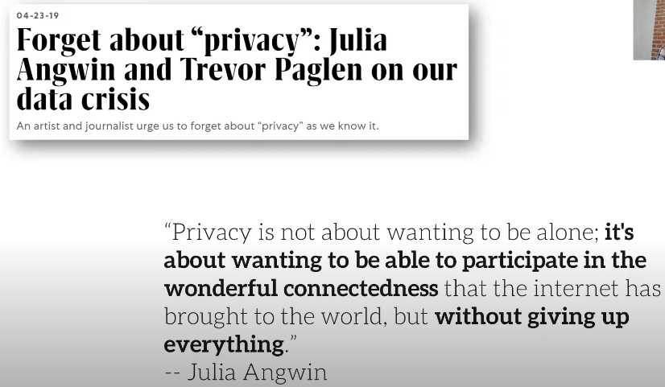

1. **Regulating data collection and political ads**

**The talk “Green chairs instead of green lights” - surveillance is not safety (military societies)**

**4 principles for responsibility by Rachel**

[**https://www.fast.ai/2020/01/21/responsible-government/**](https://www.fast.ai/2020/01/21/responsible-government/)

* Listen to local communities
* Beware how NDAs obscure public sector process and law
* Security is not the same as safety
* Policy decisions should not be outsourced as design decisions

**Zeynep’s opinions on data privacy:**

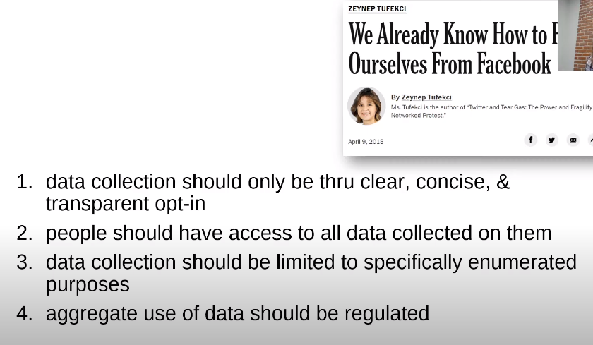

*“What we need to fear most is not what AI will do to us on its own, but how people in power will use AI to control and manipulate us.”*

Expert list:

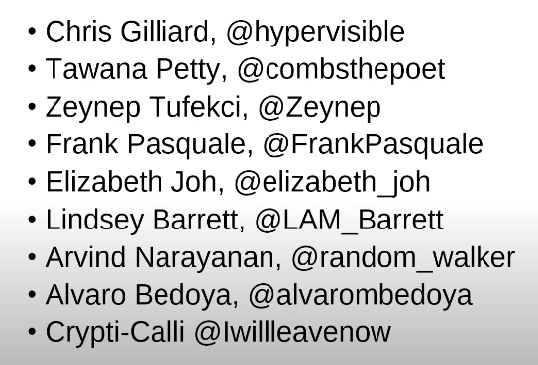

**Section 5: The problem with metrics**

Reading1:

Anthropological/ Artificial Intelligence & the Human-centered AI (HAI)

What should HAI do?

* If HAI reaches out to people from marginalized groups and public and got turned down, they should stop for a moment and reflect why. Maybe even ask those people who gave them pause and listen.
* The HAI should reconsider the leadership appointments of anyone with vested interests in proliferation of AI. My position is that we should exclude AI from outlives and from society, but that it is not credible that an organization is human-centered if it starts from a place presupposing AI’s necessity. That is AI centered, not human centered
* The HAI also thinks (much) more critically about where and who it gets money from, what those entities expect to gain from backrolling HAI, and be open to the prospect of turning away donations and grants no matter how substantial.

Reading 2: The incompatible incentives of private sector AI

Three factors that motivate companies **(social media recommendation system)** to modify their presentations (e.g., in a classification task for ppl):

1. Presentation cost: affordability to present
2. Sensitivity: changing an input is worthy only when it affects outputs
3. Impact: changing an output is worthy only when it has significant consequences

**→ algorithms with low presentation cost, high sensitivity and impact give subjects strong incentives to present → gaming and manipulation are encouraged**

**Algorithm-guardrail arbitrage: when a recommendation system encourages content that violates its community guidelines. Companies have a financial incentive to keep the gap wide.**

**Lec 5-1: Ecosystems: the problems with metrics**

1. **Goodhart’s law**: when a measure becomes a target, it ceases to be a good measure

**Campbell’s law**: “The more any quantitative social indicator is used for social decision making, the more subject it will be to corruption pressure and the more apt it will be to distort and corrupt the social processes it is intended to monitor.”

Much of AI/ML centers on optimizing a metric

Overemphasizing metrics leads to:

* Manipulation
* Gaming
* Myopic focus on short-term goals
* Unexpected negative consequences

Ex1: Measurement bias

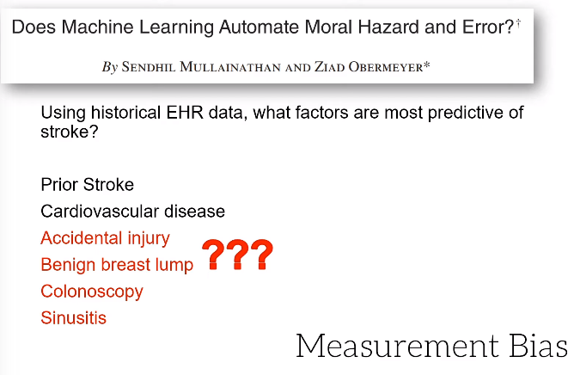

Ex2: UK’s healthcare system

The system wants to reduce the patients’ wait time for ER, which led to:

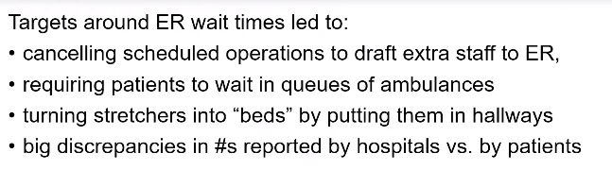

Ex3: The more pressure on the standardized exams, the more cheats there are in some school districts

<https://www.nytimes.com/2010/06/11/education/11cheat.html>

A good teacher was fired because her students’ scores were artificially higher.

Ex4: essay grading software (in 22 states now)

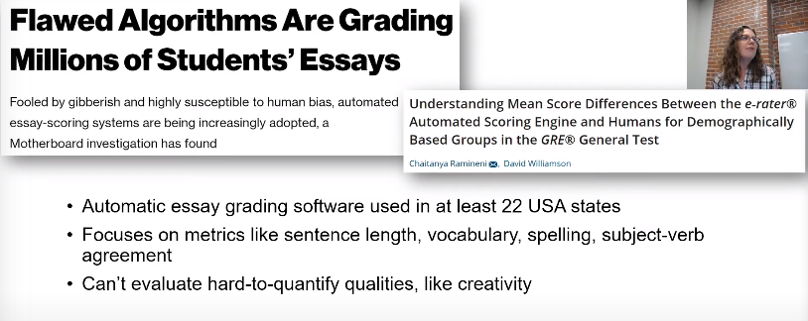

Biases: automated papers got good scores; overall lower scores from humans in US and higher scores in China

Ex5: TikiTok got much more views than the actual downloading number

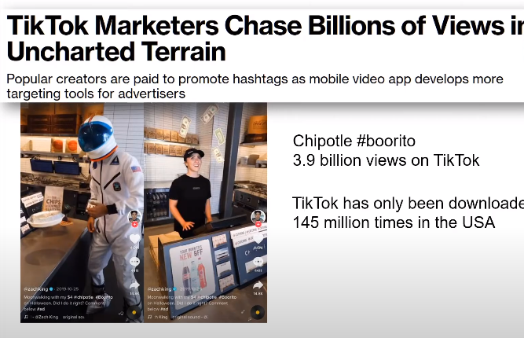

Ex6: FB exaggerated watch time by as much as 900%

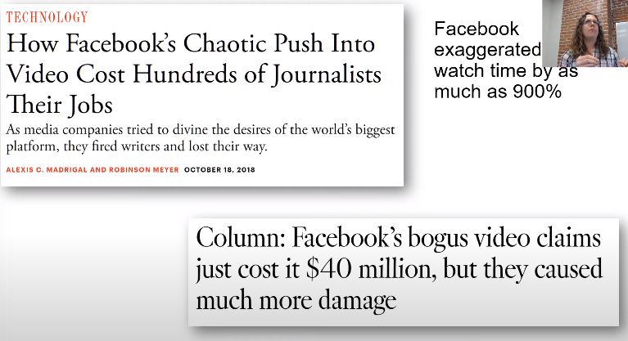

1. Failure modes of Goodhart’s law
2. Regressional Goodhart: difference between proxy and goal is important (e.g., the stroke example)
3. Extreme: relationship between proxy and goal is different when taken to an **extreme**
4. Casual Goodhart: non-causal relationship between proxy and goal, and intervening on one may fail to impact on another
5. Adversarial Good hart: adversaries attempt to game the chosen proxy

Ex7: youtube recommendation system

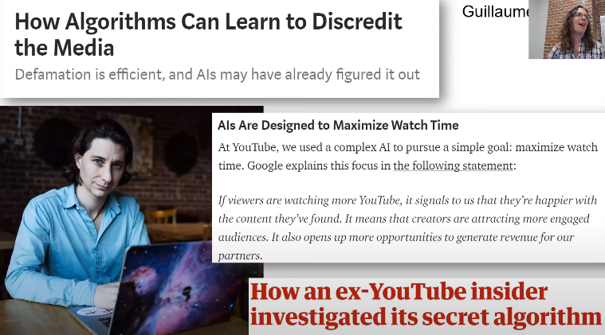

(3) wrong motivations

* Our online environments are designed to be addictive
* The incentives focus on short-term metrics
* The fundamental business model is around manipulating people’s behavior and monopolizing their time

(4) Reading: The platform is the message by James Grimmelmann

“These platforms are structurally at war with themselves. The same characteristics that make outrageous and offensive content unacceptable are what make it go viral in the first place.”

(5) Reading 3:

Tim O'Reilly argument against Reid Hoffman’s Blitzscaling in Silicon Valley

* **Blitzscaling means to achieve massive scale at incredible speed in order to seize the ground before competitors do; relying on strong network; usually at the cost of making little profit**
* FB - “move fast and break things”; Uber & Lyft; Airbnb
* Blitzscaling is not sustainable gaining and there is no consideration of social good or responsibilities
* Google now seems to seek “growth for growth”

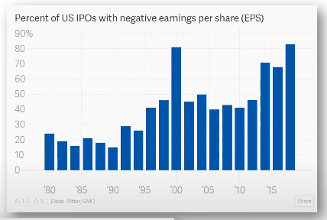

Rachel: five trends to avoid when founding a startup

1. **Venture Capital** often pushes what could’ve been a successful small business to over-expand and ultimately fail; prevents companies from focusing their priorities; distracts from finding a monetization plan; causes conflict due to the misalignment of incentives between VCs and founders; and is full of far too many unethical bullies and thugs.
2. **Hypergrowth** is nearly impossible to manage and leads to communication failures, redundant work, burnout, and high employee attrition.
3. **Trying to be “like a family”** severely limits your pool of potential employees, leaves you unprepared for conflict or HR incidents, and sets employees up to feel betrayed.
4. **Attempting to productionize a PhD thesis** is rarely a good business plan. The priorities and values of academia and business are drastically different.
5. **Hiring a bunch of academic researchers** will not improve your product and harms your company by diverting so many resources (unless your goal is an acquihire).

How is speed/hypergrowth related to data ethics?

* Hockey-stick growth requires automation and reliance on metrics
* Prioritizing speed above all else doesn’t leave time to reflect on ethics
* Problems happen at a large scale

(6) The fundamental problem with Silicon Valley’s favorite growth strategy

* Investors anoint winners (as opposed to market forces)
* Creates duopoly or monopoly
* Incredibly difficult for new entrants
* Loss of control of company
* Spread yourself too thin in trying to achieve the monopoly status
* Tons of companies using this strategy fail. Survivorship bias

(7) **Power always learns, and powerful tools always fall into its hands. This is a hard lesson of history but a solid one**.

* How did digital technologies go from empowering citizens to being used as tools of oppression and discord?
* Dissidents can more easily circumvent censorship, but the public sphere is now too noisy and confusing to have an impact.
* The new gatekeepers succeed by fueling mistrust and doubt
* Local journalism has been broken
* When we encounter opposing views on social media, it’s like hearing them from the opposing team in a football stadium
* US has weak digital security
* Conditions of social distrust, weak institutions, and detached elites made the US vulnerable

**Lec 5-2: Losing the forest for the trees: how the measure and lose track of things**

*Seeing like a state*

1. Governments make sense of the world by operationalizing it in ways that allow them to make comparisons and decisions

* Family names
* Standardized measures
* Surveys and censuses
* Organization of transportation

This makes the world legible to the state.

1. Interpretation to imposition

* We turn our messy world into data to reason about it and to inform actions

Ex1: “mother of all demos”

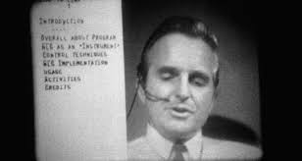

Early HCI

* That’s becoming a growing problem as we build our systems directly out of the data

Ex2: more ethical cases

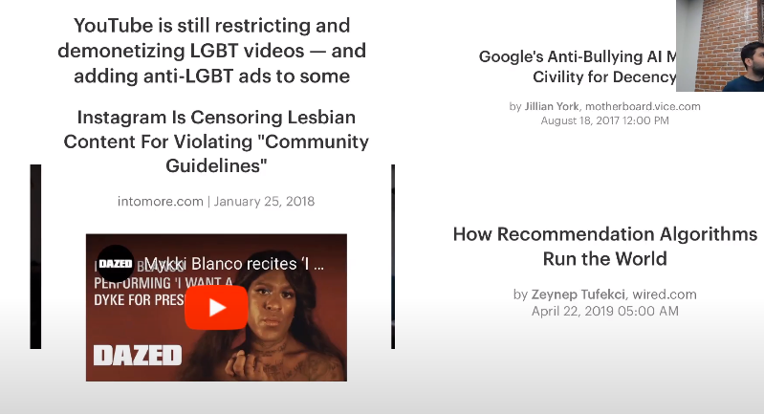

**Youtube is still restricting LGBT community**

<https://www.theverge.com/2018/6/4/17424472/youtube-lgbt-demonetization-ads-algorithm>

**Instagram Is Censoring Lesbian Content For Violating “Community Guidelines”**

<https://www.intomore.com/culture/instagram-is-censoring-lesbian-content-for-violating-community-guidelines>

**The Algorithmic Copyright Cops: Streaming Video's Robotic Overlords**

<https://www.wired.com/2012/09/streaming-videos-robotic-overlords-algorithmic-copyright-cops/>

**How recommendation algorithms run the world**

<https://www.wired.com/story/how-recommendation-algorithms-run-the-world/>

**Google’s anti-bullying AI mistakes civility for decency**

<https://www.vice.com/en_us/article/qvvv3p/googles-anti-bullying-ai-mistakes-civility-for-decency>

**Here Come AI-Enabled Cameras Meant to Sense Crime Before it Occurs**

<https://www.defenseone.com/technology/2019/04/ai-enabled-cameras-detect-crime-it-occurs-will-soon-invade-physical-world/156502/>

# **Trolls turned Tay, Microsoft’s fun millennial AI bot, into a genocidal maniac**

<https://www.washingtonpost.com/news/the-intersect/wp/2016/03/24/the-internet-turned-tay-microsofts-fun-millennial-ai-bot-into-a-genocidal-maniac/>

**Something is wrong with the internet**

<https://medium.com/@jamesbridle/something-is-wrong-on-the-internet-c39c471271d2>

**Researchers trick Tesla Autopilot into oncoming traffic**

<https://arstechnica.com/information-technology/2019/04/researchers-trick-tesla-autopilot-into-steering-into-oncoming-traffic/>

**ACLU: Facial recognition software falsely matched famous athletes to mug shot database**

<https://www.boston25news.com/news/amazon-s-facial-recognition-software-falsely-identifies-famous-athletes/999931907/>

* People respond to that; we perform for the algorithms that dictate our lives

Ways to undermine FR systems:

